**User Interface**

***Version 1.0.4.0***

* ***Quick Settings*** *-* Reworked Settings UI to have common settings in an accessible dialog
  + Clicking the *Settings* *Gear* icon now shows the quick settings dialog.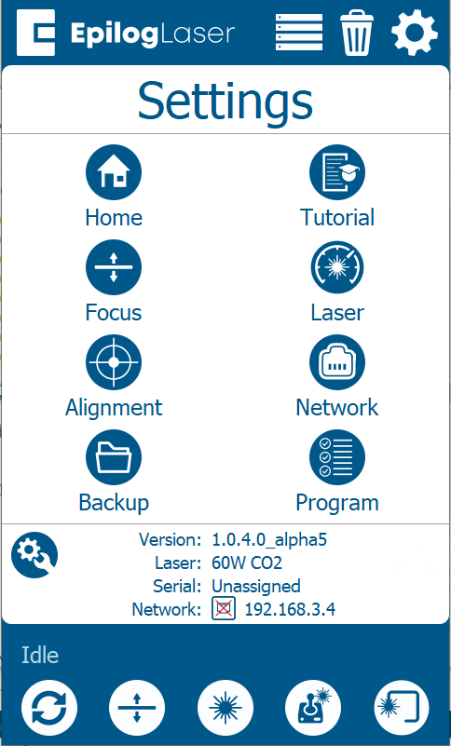
  + ***Home*** - Modify *Home Offset* and *Rotary Offset* (When rotary Present). Click the save button to save the change. Click the *Home Axis* button to home the axis.

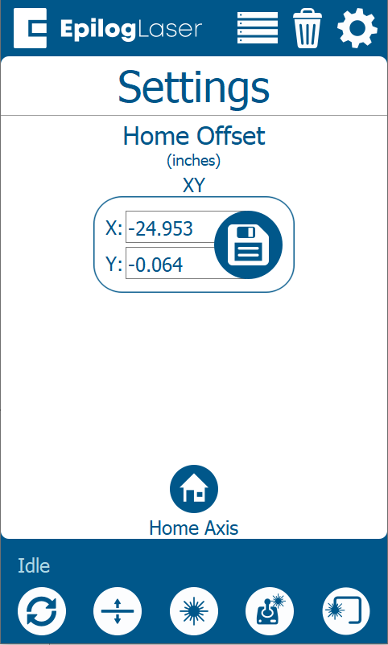

* + ***Tutorial*** - Show the Unboxing Wizard that appears on the machine first boot.
  + ***Focus*** - Show the Focus calibration items
  + ***Laser*** – Setup the laser tickle settings. Click the save button to save the changes. Use the drop down to select the laser tickle settings to use. *Custom* settings can be applied.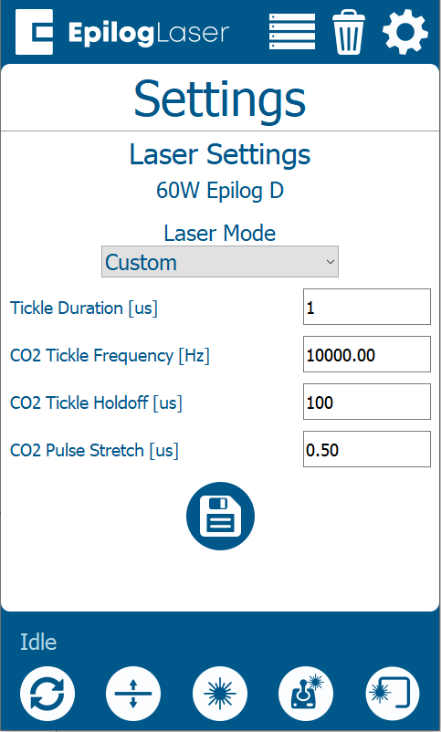
  + ***Alignment*** - Show the alignment dialog
  + ***Network*** - Show the network setup
  + ***Backup*** - Added a utility to Backup, Restore, and Reset configuration settings 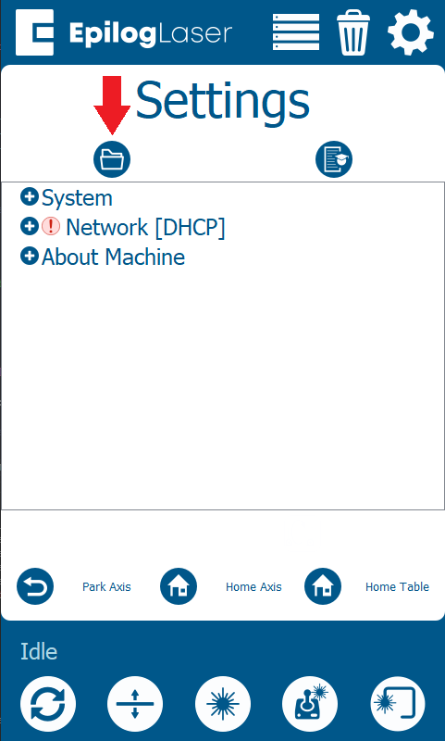 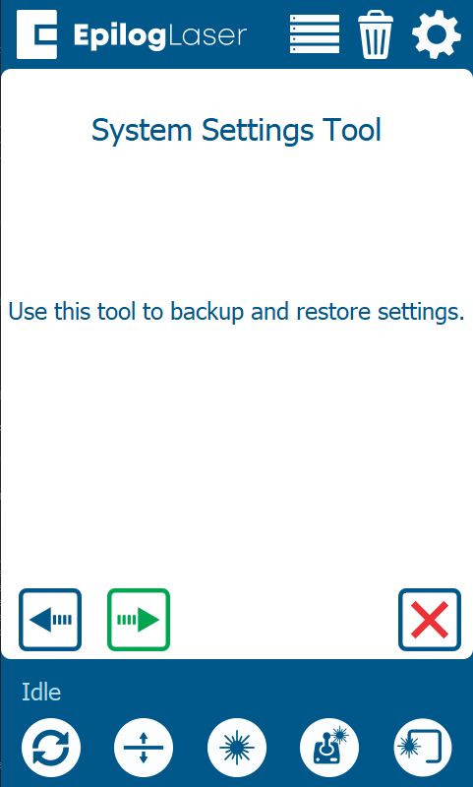 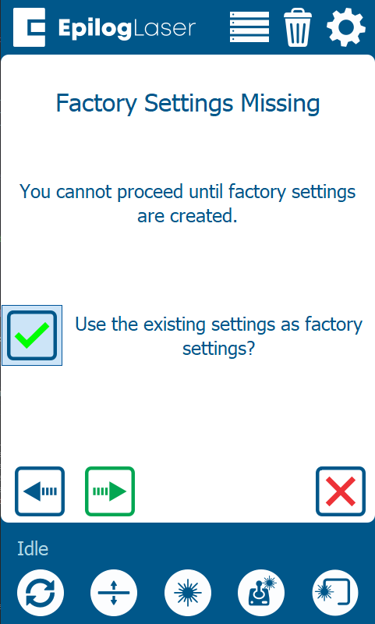 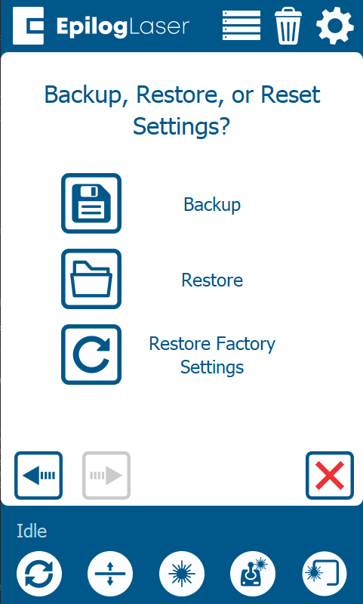 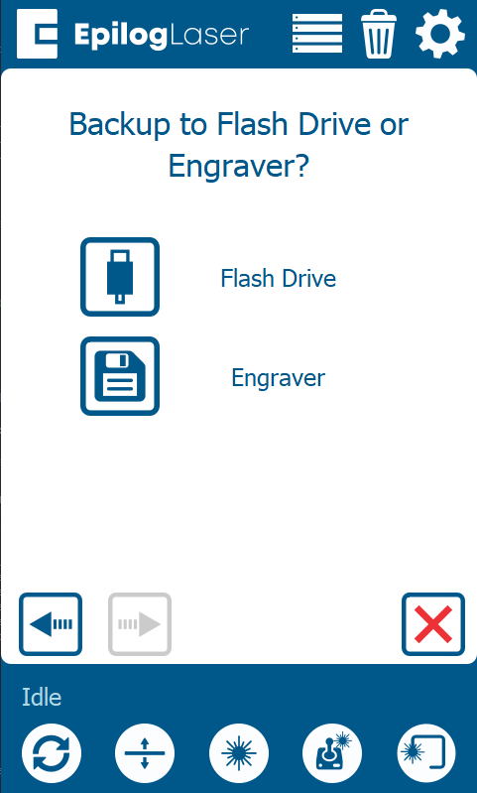 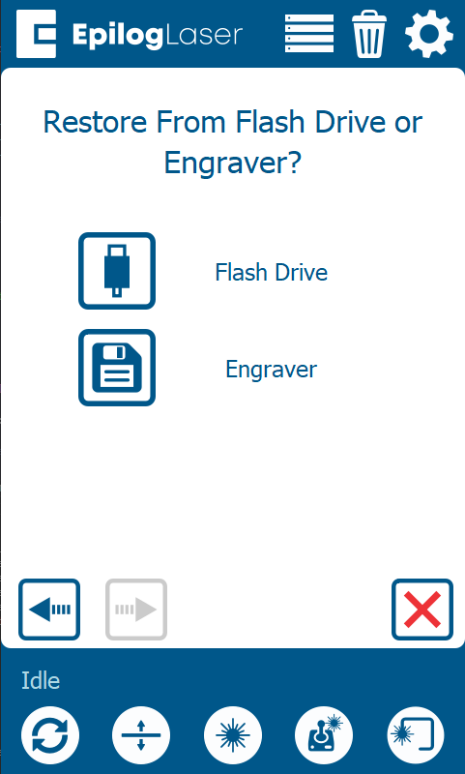

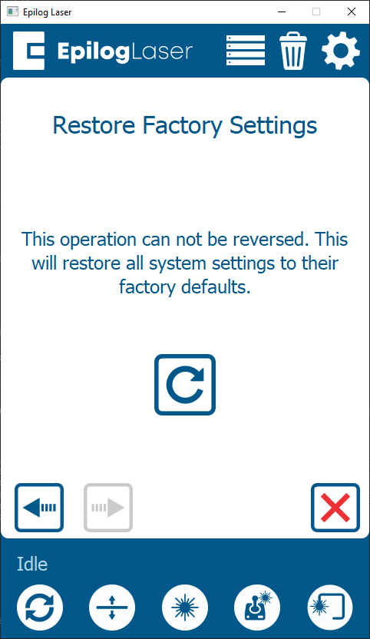 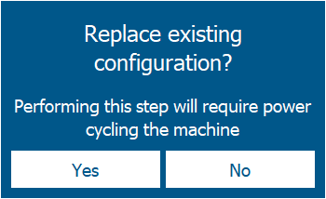

* + ***Program*** - Show the Peripheral Update screen to program the system components
* Added ability to modify Speed / Power / Frequency while job running.
  + Speed / Power / Frequency only appear if the current running process allows modification for those settings. For example, only the Power appears when rastering with a CO2 laser.  
    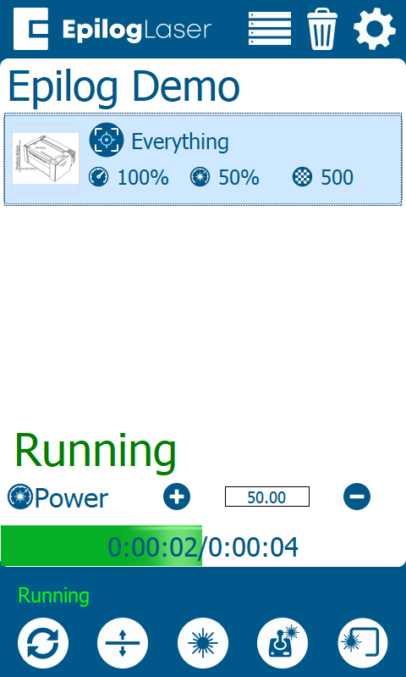

***Version 1.0.4.1***

* No changes

***Version 1.0.4.2***

* No changes

***Version 1.0.4.3***

* ***WIFI Availability Control*** – In the network settings page a control was added to enable or disable wireless networking.

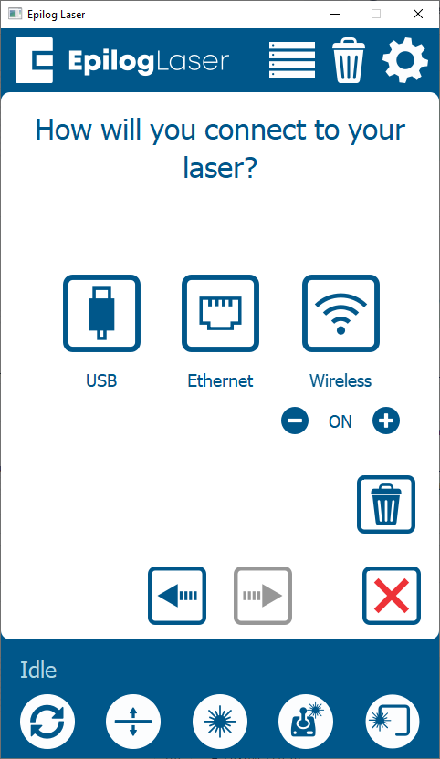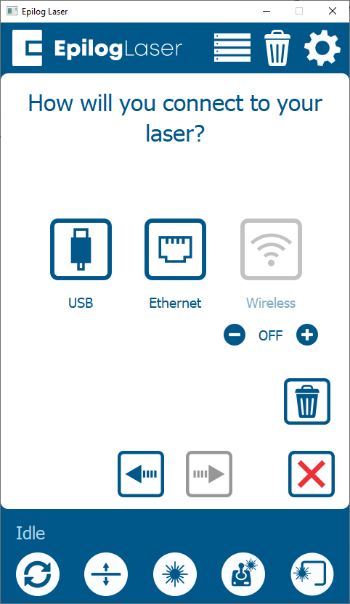

* WIFI can also be disabled all together by running a special update.

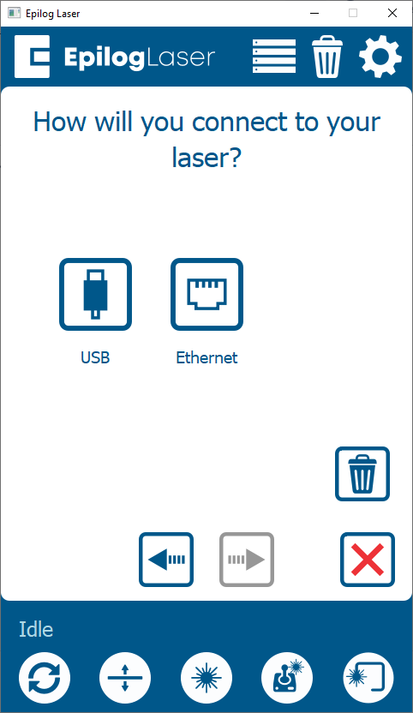

***Version 1.0.4.4***

* No changes